**Intro to Learner Management System (LMS).**

|  |
| --- |
| **Overview**  A Learning Management System (LMS) is the software that companies use to develop, deliver, and track training for their employees, clients, and partners. |

**Examples of common LMS**

* Moodle.
* Chamilo.
* Open edX.
* Totara Learn.
* Canvas.
* Blackboard
* Sakai

At Life Choices we use Moodle platform.

**Moodle Features**

* Communication tools
* Student Collaboration
* 24/7 Access
* Student/teacher interaction
* Online learning
* Digital tools
* Discussion board
* Assessment Tools

**What is Moodle?**

Modular Object-Oriented Dynamic Learning Environment (moodle) is a free and open-source e- learning software platform for Virtual Learning Environment (VLE). The aim of moodle is to create online courses with a focus on interaction and collaborative construction of content.

The link for our platform is https://academy.lifechoices.co.za/

Once you type the given link, you will be directed to the following screen where you are expected to type in your username and password. Please do not share usernames and password. You are responsible for your profile.

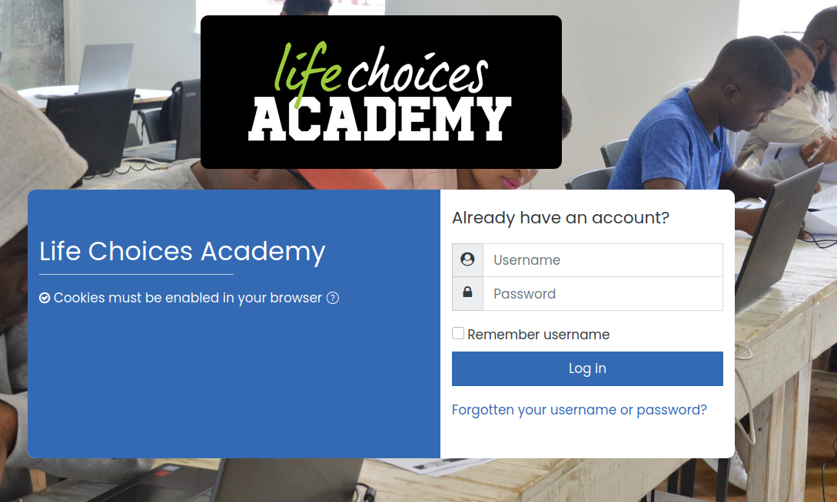

**Once you manage to log in the next screen looks like the one below.**

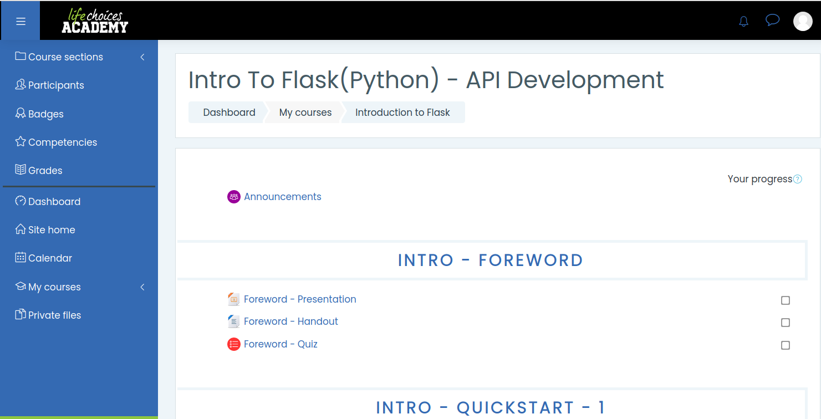

You are allowed to add your profile picture. Please take note that this is a formal platform and you are expected to comply with the regulations of the organization when uploading content and communicating with your friends.

To your left you have the following tabs:

* Participants-Shows you the people who are registered for your course.
* Badges
* Competencies
* Grades- This tab will give you access to your scores for the module(s) you are registered for.
* My Courses- Gives you access to all the courses you are registered for.

To access learning content, select the appropriate course and press enter. You will be directed to the content. The content can be a handout, PowerPoint slides, Videos, Quizzes, Tasks. Also, take note that for assignments, you are able to upload your answers in different formats such as pdf, docx, xls etc. The maximum file size permitted is 32MB.

We have added a link COURSE DETAILS FOR where you can access the following:

Calendar for the duration of the course with topics done in each week. There could be some deviations in cases where we end up taking longer for a specific topic. In addition, the link provides a document with some challenges which you will do during the course. To those who are proactive, you can start researching how to do some of these tasks.

**What can a student do in Moodle?**

* You can see all your enrolled classes at a glance;
* you can work on assignment from any computer with an Internet connection and a compatible browser;
* you can check your grades for assignments, quizzes and other tasks;
* you can contribute to forums, wikis, and glossaries that your teacher establishes;
* and you can check your course's calendar for important dates and upcoming course events.

Please familiarise yourself with the platform.

Good Luck.